DIS-Arc-Pipe-Mississippian-Cahokia

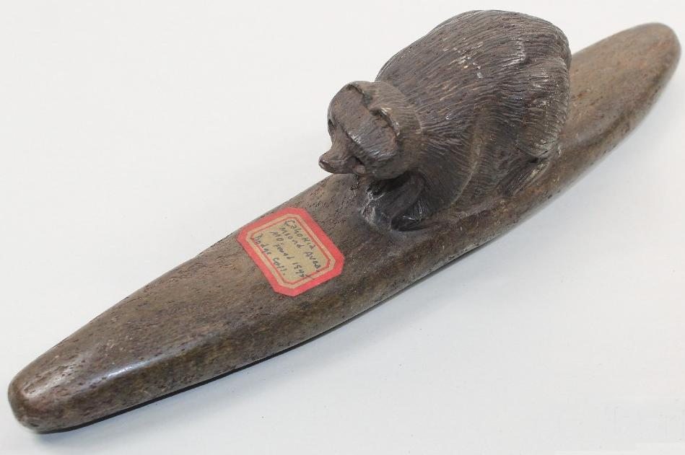

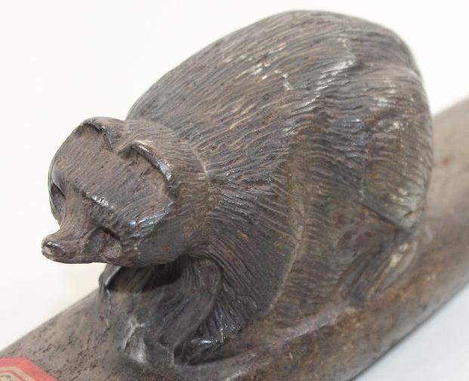L

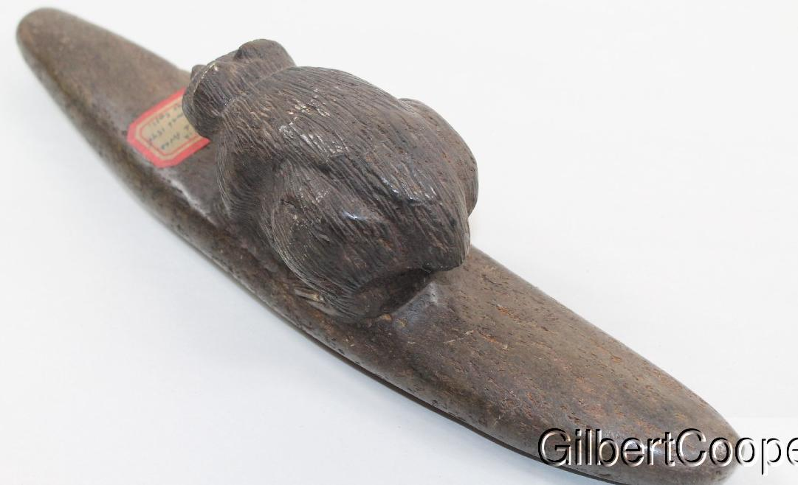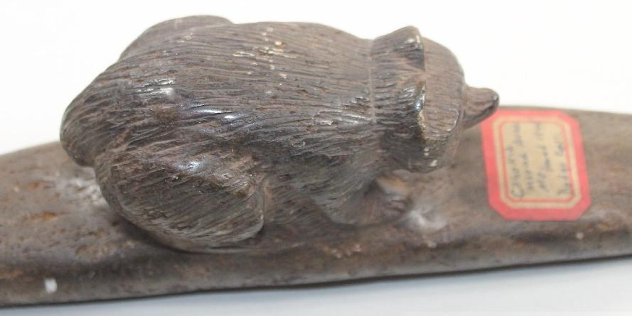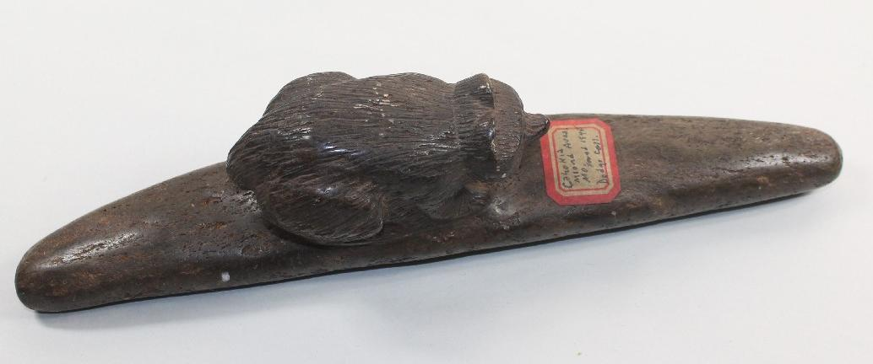

Large Cherokee Great Pipe Preform that has a Bear Effigy on it. It should date in the early 1900's. It was never drilled. There is an old sticker that reads Cahokia Area, 1845, Dodge Collection. My own personal opinion is that this piece is hands down a Cherokee piece and will date in the 1900's and has never seen the Cahokia Area. This piece measures is 12-1/2" long by 3-1/4" tall by 2-1/2" wide. It is made out of Carolina Steatite.